What is DevOps

DevOps is a modern approach to software development that brings development and operations teams together to deliver applications faster and more reliably. It focuses on collaboration, automation, and continuous improvement across the software lifecycle.
- Encourages close collaboration between development and operations teams.
- Automates build, test, and deployment processes to reduce errors.
- Enables faster and more frequent software releases.
- Improves system reliability, monitoring, and feedback loops.

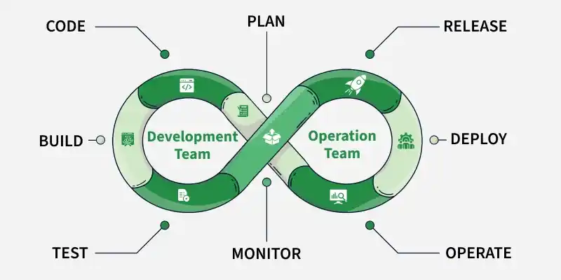

Stages of DevOps are:

Plan Stage
- Teams define project requirements, goals, timelines, and success metrics.
- Work is broken down into tasks and user stories to ensure clarity and alignment.
- Collaboration between development and operations begins at this stage to avoid future bottlenecks.
- Common Tools: Jira, Confluence, Azure Boards, Trello.

Code Stage
- Developers write application code and configuration files following best practices.
- Version control systems are used to manage changes and collaborate efficiently.
- Code reviews and branching strategies help maintain code quality and stability.
- Common Tools: Git, GitHub, GitLab, Bitbucket.

Build Stage
- The application code is automatically compiled and packaged into deployable artifacts.
- Dependencies and libraries are resolved to ensure consistent builds across environments.
- Build automation ensures faster feedback and reduces manual errors.
- Common Tools: Jenkins, GitLab CI/CD, Maven, Gradle, Docker.

Test Stage
- The software undergoes thorough testing to catch bugs and security risks before release.
- Diffrent Testing methods includes unit, integration, performance, and security testing.
- Issues are identified early, that will reduce the cost and impact of failures.
- Common Tools: Selenium, JUnit, TestNG, SonarQube, JMeter

Release Stage
- Tested builds are prepared and approved for deployment.
- Release versions are tagged and documented for traceability.
- Deployment strategies are planned to minimize risk during production rollout.
- Common Tools: Git tags, Jenkins, GitLab CI/CD, ArgoCD.

Deploy Stage
- The application is deployed to production or target environments.
- Deployment strategies such as blue-green, canary, or rolling updates are used to ensure minimal downtime.
- Infrastructure automation ensures consistency across environments.
- Common Tools: Kubernetes, Helm, Ansible, Terraform.

Operate and Monitor Stage
A key aspect of DevOps is learning from real-world performance and using that feedback to improve future releases.
- The application is continuously monitored to ensure availability and performance.
- Logs, metrics, and alerts help detect and resolve issues quickly.
- Feedback from monitoring and users is fed back into the planning stage for continuous improvement.
- Common Tools: Prometheus, Grafana, ELK Stack, Datadog, New Relic

How to Adopt a DevOps Model?
To adopt a DevOps model, ensure the following points:
- Adopt a DevOps Mindset: Adopt a devops mindset by fostering collaboration, shared ownership, and accountability across development, operations, QA, and security teams.
- Recognize Infrastructure Requirements: Recognize infrastructure requirements by assessing current workflows, identifying bottlenecks, and evaluating scalability, availability, and security needs
- Create a DevOps Strategy: Create a devops strategy by defining clear, measurable goals such as faster deployments, improved reliability, and better cross-team collaboration
- Choose the Right DevOps Tools:Choose the right devops tools that align with your workflows for version control, ci/cd, infrastructure automation, and monitoring
- Increase Test Automation: Increase test automation and align qa with development to catch defects early and ensure consistent software quality
- Adopt Application Containerization: Adopt application containerization to standardize environments, simplify deployments, and improve scalability
- Focus on iterative adoption by continuously monitoring performance, collecting feedback, and optimizing processes over time.

DevOps for AI and ML
Even though Artificial Intelligence (AI) and Machine Learning (ML) are still growing in DevOps, they are already making a big difference.
- Handling Big Data: DevOps tools generate a huge amount of data from testing, deployment, and monitoring. AI and ML are great at reading all this data quickly, finding useful insights, and helping teams make faster and smarter decisions.
- Saving Time with Smart Suggestions: AI can learn how developers and operations teams work, then suggest better ways to do tasks or automatically set up the needed tools and servers, reducing manual work.
- Spotting Bugs Early: AI and ML can look at code and test results to find problems (like bugs) early. They can detect unusual patterns that may cause issues later and warn the DevOps team before users are affected.
- Improving Security: These technologies can scan security logs and alerts to find threats, such as hacking attempts or breaches. Once something risky is found, they can even respond automatically. For example, by blocking access or sending alerts.

